A project report on

**TRAINING AND PLACEMENT CELL MANAGEMENT SYSTEM**

Submitted in partial fulfilment of the requirements for the degree of

**Bachelor of Science in Information Technology** by

22632 Abhay Vishwakarma

22602 Shivam Singh

Under the guidance of

**Asst. Prof. Sherilyn Kevin**



## Information Technology

## Thakur College of Science and Commerce,

## Kandivali (East), Mumbai - 400101.

**Bachelor in Science**

**2022-2023**

 **Thakur College of Science & Commerce**

**Project Certificate for BSc (IT) Student**

This is to certify that the project entitled Training and Placement cell Management Systems undertaken at the Thakur College of Science and Commerce by Shivam Singh (Roll No. 22602) and Abhay Vishwakarma (Roll No. 22632) in partial fulfilment of BSc (IT) degree, Semester 6 Examination has not been submitted for any other examination and does not form part of any other course undergone by the candidates.

It is further certified that they have completed all the required phases of the project.

____________________________ _____________________________

Signature Signature

External Examiner Internal Examiner

____________________________ ____________________________ Signature Signature

Project Guide HOD/In-charge/Co-ordinator

College Seal

**Acknowledgements**

We, Abhay and Shivam take pride in presenting to you, Training and Placement Cell Management System, our joint effort aimed at the direction of making people Comfortable. While this was made as an academic project, we fully intend to work better on the system even after it is submitted so that it realises its true potential. We would like to give heartfelt thanks to our teachers, who encouraged us to make a web application along with the Head of Department Mr. Santosh Singh, and in particular, to our Project Guide, Ms. Sherilyn Kevin who guided us at every step of this tortuous journey, correcting our mistakes, applauding our successes, and always encouraging to push ourselves to the maximum.

Besides, we would also like to thank all our classmates, who have helped us at every stage of the process – both directly and indirectly, without whom Training and Placement Cell Management System would not have been as good as it is today.

**TABLE OF CONTENT -**

|  |  |  |  |
| --- | --- | --- | --- |
| Sr No |  | TOPIC | Pg No |
| 1 |  | Introduction |  |
|  | a. | Objective | 1 |
|  | b. | Scope of the project | 1 |
|  | c. | Theoretical Background | 2 |
|  | d. | Problem Definition | 2 |
|  | e. | Functional Requirements/SRS | 3 |
|  | f. | Non-Functional Requirement | 5 |
|  | g. | Feasibility Study | 6 |
|  | h. | Detail of Hardware and Software | 7 |
| 2 |  | System Analysis and Design |  |
|  | a. | Detailed Lifecycle of the project | 8 |
|  | b. | CONTEXT Diagram | 10 |
|  | c. | USE CASE Diagram | 11 |
|  | d. | DFD Diagram | 14 |
|  | e. | ER Diagram | 15 |
|  |  |  |  |
| 3 |  | System Planning |  |
|  | a. | Gantt Chart | 16 |
|  | b. | Pert Chart | 17 |
| 4 |  | Cost and Benefit Analysis | 18 |
| 5 |  | References | 20 |
|  |  |  |  |
|  |  |  |  |
|  |  |  |  |

1. **Introduction**
2. ***Objective:***

This project is mainly intended for automating this procedure that can help the people who belong to the T&P cell by saving their time ,based on this basic operation actually their activity is under two steps the first one is, to maintain the list of students and their credit records and the second job is to maintain the company details and based on the company requirements, need to select the students and make the list of students branch wise, which is more complex task, and here informing is through notice boards , where as this is also a bit old fashioned task, which can be automated in our proposed system by sending mails to the respective candidates. This proposed system is far advantageous than the existing one in many cases such as retrieving the student details is easily maintained in a manner that with just one click we can easily attain the details of the company such as the responsible person contacts and company contact details such as address and phone numbers can be maintained. T&P cell mainly include the details of students. The percentage of the students must be appropriate and true. The notices can be generated, so that we notify all the departments the corresponding information about campus recruitment drives. The student detail can also be viewed.

1. ***Scope of Project:***

The project covers a wide scope. The information of all the students gets stored in the Database. Student will be also able to upload their CV’s. Company HR and TPO can access the information. Students can maintain their information and can update it. Various Facilities provided are:

* Student Registration facility
* Student Login
* Upload Student details
* Company HR Login
* HR can update the Job Status
* HR can upload Company/Job Details
* Training And Placement Officer (TPO) Login
* HR and TPCO can view Student Details

**c) *Theoretical Background :***

Now a day , student join college for better education as well as for better placement for their future . The placement activities plays very important role in student career and building college reputation. In current system all training and placement activities are done manually there are more chances of error . It is very time consuming activities for collecting , managing , updating student data as number of student increases . The notice board is old method of informing student about the placement activities . The training and placement officer has to short list according to company requirement . It is required to design of computerized student automation module to speed up capabilities .

Now a day , student joins the college for better education as well as for better placement for their future. The

placement activities plays very important role in student career and building college reputation. In the current system all

training and placement activities are done manually, there are more chances of error. It is very time consuming activity

for collecting, managing , updating student data as number of student increases. The notice board is old method of

informing student about the placement activities. The training and placement officer has to short list according to

company requirement. It is required to design of a computerized student automation module to speed up capabilitie

Now a day , student joins the college for better education as well as for better placement for their future. The

placement activities plays very important role in student career and building college reputation. In the current system all

training and placement activities are done manually, there are more chances of error. It is very time consuming activity

for collecting, managing , updating student data as number of student increases. The notice board is old method of

informing student about the placement activities. The training and placement officer has to short list according to

company requirement. It is required to design of a computerized student automation module to speed up capabilitie

Now a day , student joins the college for better education as well as for better placement for their future. The

placement activities plays very important role in student career and building college reputation. In the current system all

training and placement activities are done manually, there are more chances of error. It is very time consuming activity

for collecting, managing , updating student data as number of student increases. The notice board is old method of

informing student about the placement activities. The training and placement officer has to short list according to

company requirement. It is required to design of a computerized student automation module to speed up capabilitie

Now a day , student joins the college for better education as well as for better placement for their future. The

placement activities plays very important role in student career and building college reputation. In the current system all

training and placement activities are done manually, there are more chances of error. It is very time consuming activity

for collecting, managing , updating student data as number of student increases. The notice board is old method of

informing student about the placement activities. The training and placement officer has to short list according to

company requirement. It is required to design of a computerized student automation module to speed up capabilitie

Now a day , student joins the college for better education as well as for better placement for their future. The

placement activities plays very important role in student career and building college reputation. In the current system all

training and placement activities are done manually, there are more chances of error. It is very time consuming activity

for collecting, managing , updating student data as number of student increases. The notice board is old method of

informing student about the placement activities. The training and placement officer has to short list according to

company requirement. It is required to design of a computerized student automation module to speed up capabilitie

Now a day , student joins the college for better education as well as for better placement for their future. The

placement activities plays very important role in student career and building college reputation. In the current system all

training and placement activities are done manually, there are more chances of error. It is very time consuming activity

for collecting, managing , updating student data as number of student increases. The notice board is old method of

informing student about the placement activities. The training and placement officer has to short list according to

company requirement. It is required to design of a computerized student automation module to speed up capabilitie

Now a day , student joins the college for better education as well as for better placement for their future. The

placement activities plays very important role in student career and building college reputation. In the current system all

training and placement activities are done manually, there are more chances of error. It is very time consuming activity

for collecting, managing , updating student data as number of student increases. The notice board is old method of

informing student about the placement activities. The training and placement officer has to short list according to

company requirement. It is required to design of a computerized student automation module to speed up capabiliti

1. Now a day , student joins the college for better education as well as for better placement for their future. The
2. placement activities plays very important role in student career and building college reputation. In the current system all
3. training and placement activities are done manually, there are more chances of error. It is very time consuming activity
4. for collecting, managing , updating student data as number of student increases. The notice board is old method of
5. informing student about the placement activities. The training and placement officer has to short list according to
6. company requirement. It is required to design of a computerized student automation module to speed up capabilitie
7. ***Problem Definition:***

This project is aimed at developing an online application for the Training and Placement Dept. of the college. The system is an online application that can be accessed throughout the organization and outside as well with proper login provided. This system can be used as an application for the TPO of the college to manage the student information with regards to placement. Students logging should be able to upload their information in the form of a CV. Visitors/Company representatives

***e) Functional Requirement/SRS:***

Functional Requirement :-

A student should be able to login to the system through the first page of the application, and mention his required user name and he should get his details which he can view and update it. An administrator can login into his account and he will edit the student information.

1. User Module
2. Student

* This Module consists of a Login Option and a Registration Window for Unregistered Students.
* The Student will have to use their Email and Password to Login once registered.
* The Functionalities provided in this module are as follows –

1. Once logged in, Will be able to Upload his Personal and Academic details + CV/Resume.
2. Will be able to see the Job Details and Placement Procedure (Company Name) uploaded by the HR and given link to apply for that Role.
3. Once applied for the role, He will be able to check the Status of his Job application.
4. Admin Module

2) Training and Placement Officer (TPO) - Will be Given a Specific Username and Password to Login.

Functionalities: -

* Should be able to view the Details put up by the Students and Job Roles they’ve applied for.
* Should be able to view the interaction between Students and Company HR i.e Check Job Application Status.
* Students will have to contact TPO in-person once they have established communication (through E-Mail) with the Company related to Job.

1. Company HR - Company HR will be given a Specific Username and Password to Login.

Functionalities: -

* Once the HR has logged in, He/She will be able to View the Details put up the Students and the Job Roles they’ve applied for.
* Once He/She finds an eligible candidate, he would have to Mail the student regarding the Placement Details.
* Will be able to update the Status of the Student’s application regarding the Job.

Software Requirement Specification :-

The software requirement specification is prepared at the completion of the analytical task. The function and performance assigned to the software are refined as part of the system engineering process by establishing a complete information description, a detailed functional and behavioral description, an indication of performance requirements and design constraints, proper evaluation criteria, and other statistical details.

1. User Interface Requirement –

The user of the proposed system requires that the developed software should be user friendly, have security access, and ensure the privacy of the administrator and produce results in timely manner. The users are not frequently exposed to the Training and Placement interface to the user must be simple and understandable.

The Web application mat be user-friendly and must be in an easy-to-use style. The user must be able to easily switch among various LO screens. The system is well designed so that can be used easily by users. The system should be designed in such a way that only authorized users should be allowed to login to the system

The user interface should be as interactive as possible. A user-friendly interface must be provided so that the user can easily interact with the system and comprehend things in a quicker and easier way. The system mat provide reliable and up-to-date information

The application should be efficient so that the user does not spend much time in training Consistency will increase the confidence of the user in the reliability of the application

1. Database Requirements –

The database should be designed in such a way that enhances the efficient storage, retrieval and manipulation of all the information associated. For instance all general information regarding an item attribute should be stored in a particular table. The concerned users should have the facility query to the database and supply the basic information easily. Security mechanisms should be provided so that no confidential details should be accessible to unauthorized persons. The database should be organized in such a way that it helps in preparing various essential summaries needed for users.

***f) Non-Functional Requirement***

Non-Functional Requirements are the constraints or the requirements imposed on the system. They specify the quality attribute of the software. Non-Functional Requirements deal with issues like scalability, maintainability, performance, portability, security, reliability, and many more. Non-Functional Requirements address vital issues of quality for software systems. If NFRs not addressed properly, the results can include:

* Users, clients, and developers are unsatisfied.
* Inconsistent software.

Types of Non-functional Requirement :

1. Performance
2. Scalability
3. Maintainability
4. Capacity

***g) Feasibility Study –***

The purpose of the feasibility study is not to solve the problem, but to determine the problem is worth solving. This helps to decide whether to proceed with the problem or not. It involves the analysis of the problem & collection of all relevant information relating to the product such as items that would be input to the system, processing required to carried those data, the output data required to be produced by the system as well the various constraints on the behavior of the system. "Training and placement management system” had undergone the feasibility study so that the proposed system is possible for development deployment in our college. The feasibility study concentrates on the following, such as Operational Feasibility, Technical Feasibility, Economic Feasibility

A. ECONOMIC FEASIBILITY

The economic feasibility study evaluate the cost software development against the ultimate income or benefits get from the developed system. There must be scope for profit after the success completion of the project.

B. TECHNICAL FEASIBILITY

Technical feasibility study compares the level of technology available in the software development firm and the level of technology required for the development of the product. The level of technology consists of the programming language, the hardware resources, other software tools etc.

C. OPERATIONAL FEASIBILITY

Operational feasibility study tests the operational scope of the software to be developed. The proposed software must have high operational feasibility. The usability will be high..

***h) Details of Hardware and Software –***

1. Software requirement –
2. Web server for Database Management: XAMPP Server
3. Code Editor: Microsoft Visual Studio Code

The following requirements should be met by the system:

* Keep track of any new training enrollments, it should store information about new entry of training.
* Assist internal personnel in maintaining placement information and locating them in response to various enquiries, help the internal staff to keep information of placement and find them as per different doubts .
* Retain a student's record, it should keep track of all the student’s data to see later if it matches all the job requirements .
* Update and delete the record.
* Area for searching, it should have a search area to facilitate specific job application seek .
* To avoid data leakage, a security system, it should have a security system to prevent data leakage, we wouldn't want a student's personal information out on the internet for everyone to see.
* The platform used is Microsoft Visual Studio, the language PHP and for the database MYSQL.

1. Hardware requirements –

The hardware requirements are the requirements of the hardware device. For this application it can be considered as to be stand-alone single use system. The basic requirement for the hardware for the system is the internet connectivity. A processor intel dual core and above is required, for internet connection a data card, router can be essential for the project.

**2) SYSTEM ANALYSIS AND DESIGN**

**a) DETAIL LIFECYLE OF THE PROJECT**

**INCREMENTAL MODEL –**

Incremental Model is a process of software development where requirements divided into multiple standalone modules of the software development cycle. In this model, each module goes through the requirements, design, implementation and testing phases. Every subsequent release of the module adds function to the previous release. The process continues until the complete system achieved.

## The various phases of incremental model are as follows:

**1. Requirement analysis:** In the first phase of the incremental model, the product analysis expertise identifies the requirements. And the system functional requirements are understood by the requirement analysis team. To develop the software under the incremental model, this phase performs a crucial role.

**2. Design & Development:** In this phase of the Incremental model of SDLC, the design of the system functionality and the development method are finished with success. When software develops new practicality, the incremental model uses style and development phase.

**3. Testing:** In the incremental model, the testing phase checks the performance of each existing function as well as additional functionality. In the testing phase, the various methods are used to test the behaviour of each task.

**4. Implementation:** Implementation phase enables the coding phase of the development system. It involves the final coding that design in the designing and development phase and tests the functionality in the testing phase. After completion of this phase, the number of the product working is enhanced and upgraded up to the final system product.

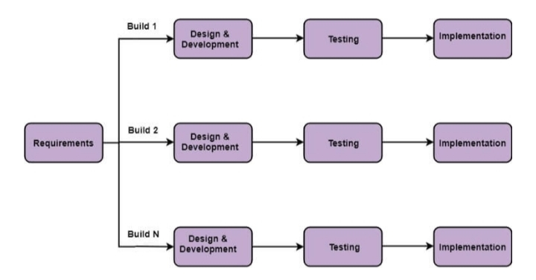

**Incremental Model**

**b) CONTEXT DIAGRAM**

Context model is a formal or semi-formal description of the context information. It is used to represent the reusable context information of the components. It identifies the flows of information between the system and external entities. This is the context model of training and Placement cell . It's a basic overview of the whole training and Placement cell or process being analyzed or modeled. It's designed as a “ At-a-glance view “ of College, Applicant and Qualification showing the system as a single high-level process, with its relationship to external entities of Placements, Training and Job. It should be easily understood by a wide audience, including Placements, Job and College.

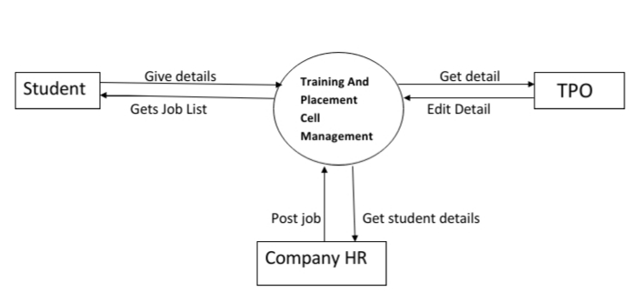

**c) USE CASE DIAGRAM**

A use case is a written description of how users will perform tasks on your website. It outlines, from a user’s point of view, a system’s behavior as it responds to a request. Use case diagrams are used to represent the functions of a system and the actors involved in it using those functions. A function may be defined as a set of actions that the business users want the software to support in order to do what is needed.

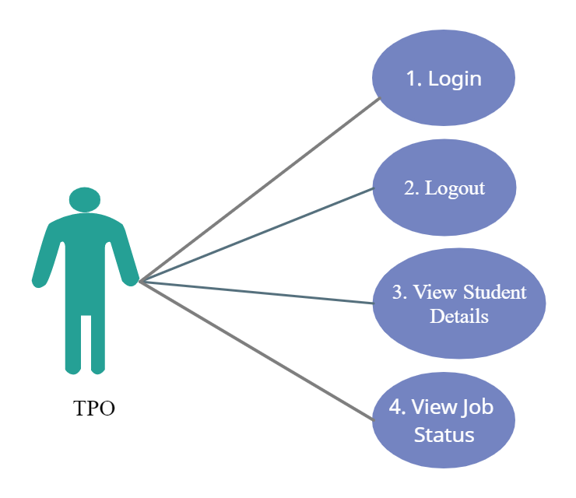

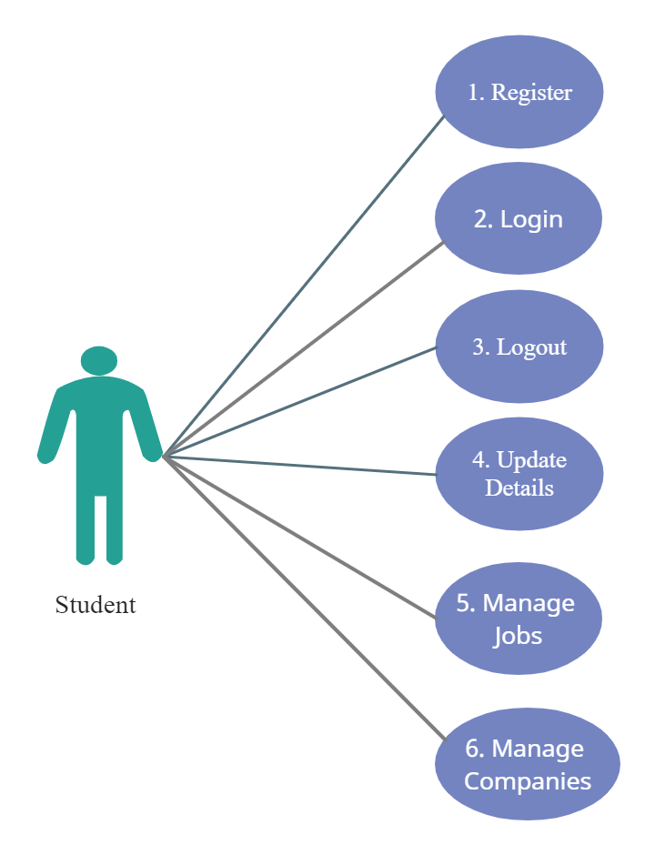

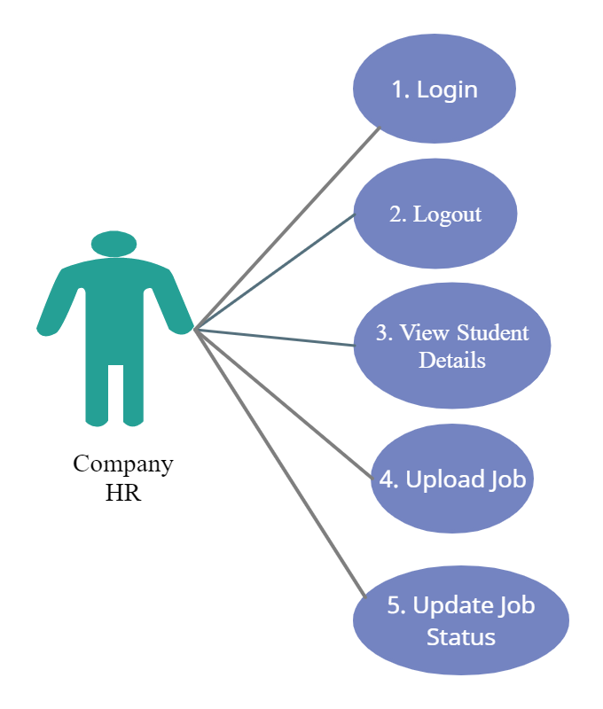

**d) DATA FLOW DIAGRAM**

Data flow describes the information transferring between different parts of the systems. The arrow symbol is the symbol of data flow. Basically it represents the flow of the data. Here in this data flow diagram of Training and Placement Cell Management System.

Student

Login and Give his Details

View Company and Jobs

Edit Student

TPO

View Student details Database

Get students detail

Post Job and Update Status

HR

**e) ENTITY RELATIONSHIP DIAGRAM**

An entity relationship diagram is a graphical representation that depicts relationship among people, objects, places, concepts or event within an information technology system. This ER diagram shows all the visual instrument of database tables and the relations between user, company, admin, job, training, etc. It shows the basic entity required and their attributes .Entity relationship consist of information required for each entity.

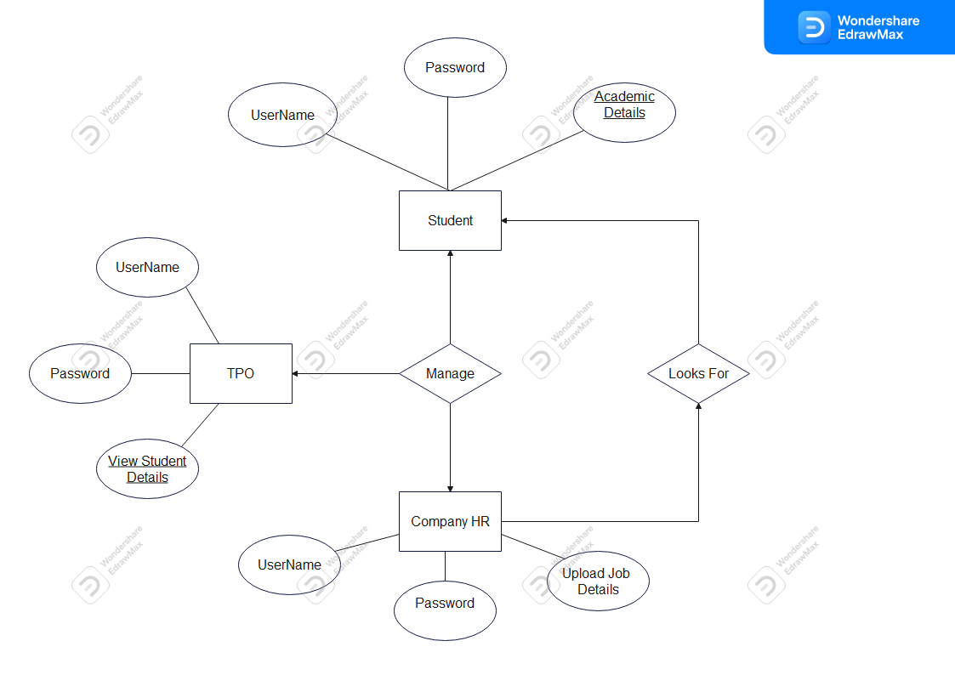

**3) SYSTEM PLANNING**

**a) GANTT CHART**

A Gantt chart, commonly used in project management, is one of the most popular and useful ways of showing activities (tasks or events) displayed against time. On the left of the chart is a list of the activities and along the top is a suitable time scale. Each activity is represented by a bar; the position and length of the bar reflects the start date, duration and end date of the activity. This allows you to see at a glance:

1. What the various activities are

2. When each activity begins and ends

3. How long each activity is scheduled to last

4. Where activities overlap with other activities, and by how much

5. The start and end date of the whole project

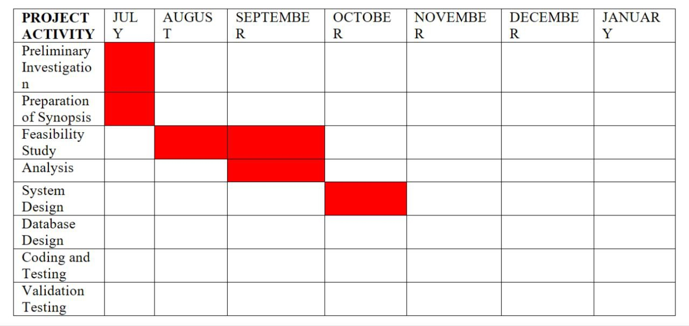

**b) PERT CHART**

The most sophisticated planning method is the Program Evaluation and Review Technique (PERT). This method, developed in 1958 by the US Navy and Booze, Allen, and Hamilton, a management consulting firm, and been used in many complex projects requiring careful planning and management.

Information system projects must be planned carefully if they are to meet important development schedules. The time required to develop a system can be estimated by using historical records of the effort needed to develop similar projects. Sometimes experience or intuition is the basis of estimates. A third method uses a standard formula that takes into account program and personnel characteristics.

Both project hour requirements, the number of personnel hours needed to develop a system, and the number of calendar days are important in estimating development time. PERT allows analysts to identify and assess the interdependence of activities in a project.

Although the best approach to project management is to break the project into small manageable pieces, there is a danger of losing sight of the overall project while supervising the smaller tasks. The PERT chart is most valuable when a project is being planned and designed. When the network is finished, it is studied to determine the critical path over which the total time required will be greater than for any other path. If activities along this path are not completed on time, the entire project will be late. PERT also show the interdependencies of the tasks and assists in answering three common management questions:

1) What other activities must precede or be completed before the initiation of a specific activity?

2) What other activities can be performed while a specific activity is in progress?

3) What activities cannot be started until after the completion of a specific activity?

**4) COST AND BENEFIT ANALYSIS AND SOFTWARE PARAMETER ESTIMATION**

**Factors Affecting Cost Estimation of the Project –**

1. Type of Software – Web Application

2. New Software Development – New software, Involving custom development.

This particular software is built from scratch and is authentic and caters to the user’s needs and demands.

3. Size of Software: Medium

4. Number of team members: 2 Members

5. Time Frame- 7 months

**Estimation of cost is done considering the above factors and using COCOMO Model:**

**COCOMO Model:**

COCOMO (Constructive Cost Estimation Model) in 1981.COCOMO is one of the most generally used software estimation models in the world. COCOMO predicts the efforts and schedule of a software product based on the size of the software.

**The necessary steps in this model are:**

1. Get an initial estimate of the development effort from evaluation of thousands of delivered lines of source code (KDLOC).
2. Determine a set of 15 multiplying factors from various attributes of the project.
3. Calculate the effort estimate by multiplying the initial estimate with all the multiplying factors i.e., multiply the values in step1 and step2.

The initial estimate (also called nominal estimate) is determined by an equation of the form used in the static single variable models, using KDLOC as the measure of the size. To determine the initial effort Ei in person-months the equation used is of the type is shown below

**Ei = a*(KDLOC)b**

**In COCOMO, projects are categorized into three types:**

1. Organic
2. Semidetached
3. Embedded

|  |  |  |  |  |
| --- | --- | --- | --- | --- |
| Type | a | b | c | d |
| Organic | 2.4 | 1.05 | 2.5 | 0.38 |
| Semi-Detached | 3.0 | 1.12 | 2.5 | 0.35 |
| Embedded | 3.6 | 1.20 | 2.5 | 0.32 |

Our model is based on Semi-Detached type.

Calculation –

1) Effort

KLOC = 4 , a = 3 , b = 1.12 , c = 2.5 , d = 0.35

Effort = a(KLOC)^b

= 3(4)^1.12

= 14.171

Effort = 14.171

Development time = c(Effort)^d

= 2.5(14.171)^0.35

= 6.323

Development time = 6.323

P = E/D

= 14.171/6.323

= 2.24

No of people (P) = 2.24

**REFERENCE**

1. https://www.tcsc.edu.in/page/placements
2. www.w3schools.com
3. https://www.mysql.com/
4. Santosh Kumar H,” Online Training and Placement Management system” ,International Journal of Engineering Research Technology (IJERT),ICACT - 2016 Conference Proceedings